# Content Navigator sample application

This document describes how to install and configure the Content Navigator sample application built using the IBM BA Studio Content Services Toolkit. By default, the application browses a FileNet Content Manager repository.

## Import the application

Go to the Apps node in BA Studio, click the Import button, browse to the Content_Navigator - 0.0.*X*.twx file downloaded from the GitHub repository, then click OK:

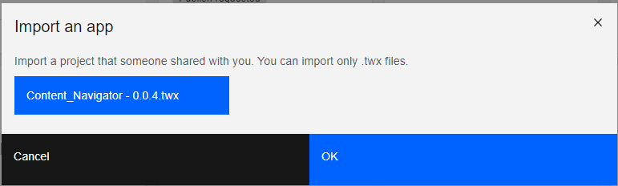

The application appears in the application project list:

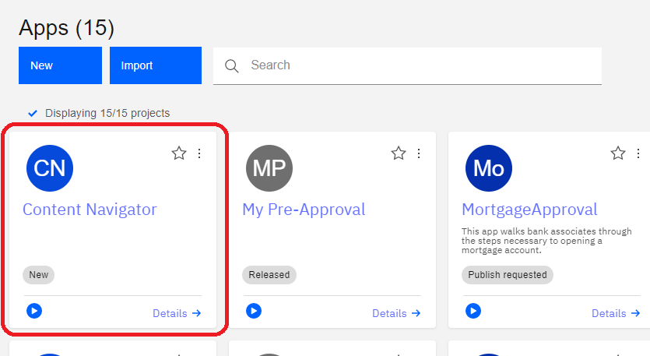

## Configure the Application Resource

Click on the application in the project list to open it, then select App Project Settings from the dropdown list in the upper left part of the page:

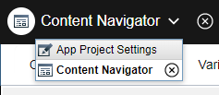

Next, click on the App Resource tab:

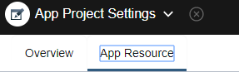

The app resource is displayed. Modify the host name and port to point to the FileNet Content Manager Graphql server in your environment. Check the Secure server box if your Graphql server is using HTTPS.



Add a user name and password to the authentication section to be used when authenticating to the Graphql server and FileNet Content Manager:

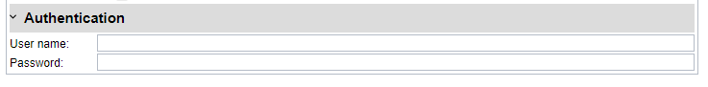

**NOTE**: These credentials will be used by all users to authenticate to the Graphql server and FileNet Content Manager.

## Configure the Document list view

Select Content Navigator from the dropdown list in the upper left part of the page:

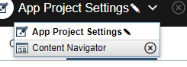

Then select Starting Page from the Page dropdown list:

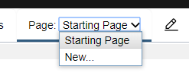

The starting page for the application displays with the Document and Property list views:

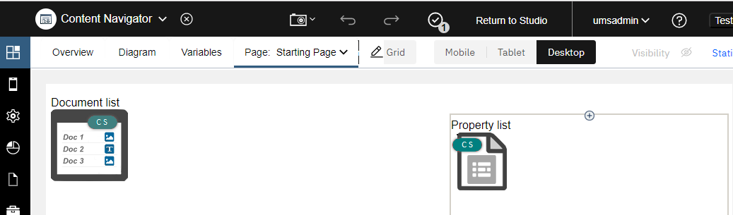

Click on the Document list view. A row of icons is displayed below the view:

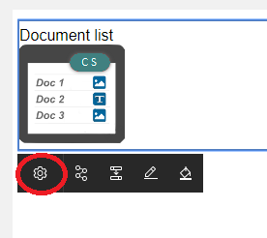

Click the leftmost icon to display the Document list properties, then click the Configuration tab:

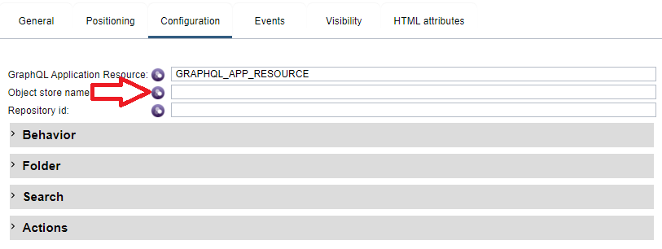

Enter the symbolic name of the object store you wish to browse into the Object store name field. The object store must exist in the FileNet domain pointed to by the Graphql app resource.

By default, the application browses the object store starting at the root folder, allowing users to navigate the folders in the object store. This option is set in the Folder section of the Configuration pane:

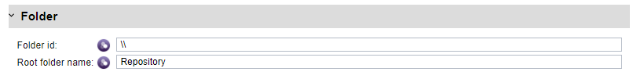

The application can be configured to browse starting at a different folder by entering either a folder id or path in the Folder id field.

The application can also be configured to display search results by entering search criteria in the Search section of the configuration pane:

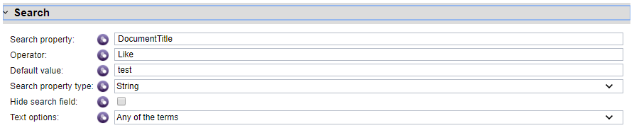

When both a folder id and search criteria are specified, the folder id is used to display the contents of the folder.

Click the “x” in the Document list properties dialog to dismiss it.

## Configure the Property list view

Select the Property list, then click the Properties icon. You may need to scroll down to see it:

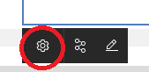

Next, click the Configuration tab:

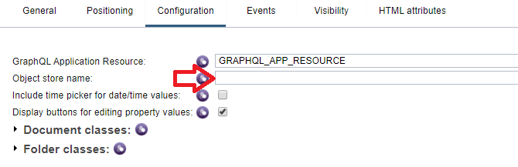

Enter the symbolic name of the object store in the Object store name field as was done earlier for the Document list.

Next, click the “x” in the Properties dialog to close it.

## Save and publish your changes

Click the check mark icon in the banner of the page to save your changes:

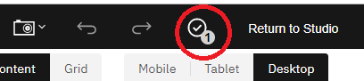

Then, click the Test button in the upper right of the page to publish and run the application:



## Using the sample application

The application browses the folder hierarchy in a FileNet Content Manager object store. To navigate into a folder, click the folder name link. To navigate up the folder hierarchy, use the breadcrumb at the top of the document list. To add new documents or folders, click the “+” button at the top of the document list:

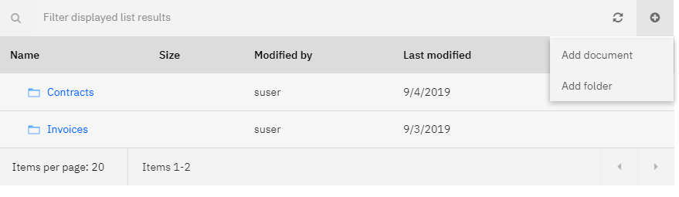

To display context menu for individual item, click on the far right of a folder or document row:

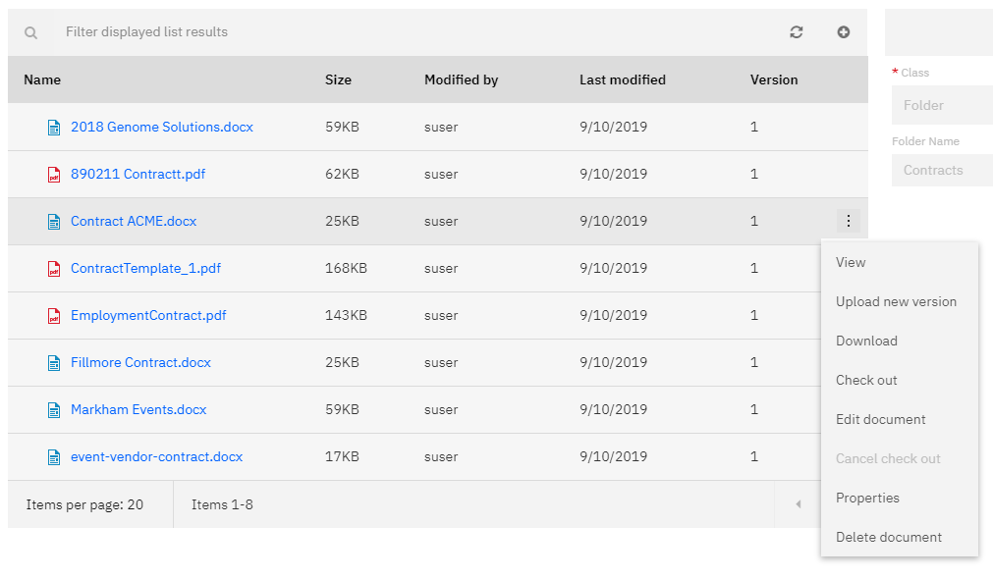

Clicking on the name of an item displays its properties in the right pane. Properties may be edited and saved by clicking the buttons at the top of the properties view.